R Tejashree (Superset ID : 6419704)

WEEK 5

Creating Microservices for Account and Loan

Prerequisites
- Eclipse IDE with Spring Tools plugin installed (Install via: Help > Eclipse Marketplace > Search for “Spring Tools” or "Spring Boot")
- Maven and Java properly set up
- Working Internet connection to download dependencies

How to Install Spring Tools Plugin in Eclipse

Step 1: Open Eclipse Marketplace
Open Eclipse. From the top menu, go to: Help > Eclipse Marketplace...

Step 2: Search for Spring Plugin
In the Eclipse Marketplace window, use the search bar.
Type: Spring Tools or Spring Boot.
Look for a plugin named something like:
- Spring Tools (aka Spring IDE and Spring Tool Suite)
- Or Spring Tools 4 for Eclipse

Step 3: Install Plugin
Click Install next to the plugin. Proceed with all defaults.
Accept licenses and wait for it to download. After installation, Eclipse will ask to restart — click Restart Now.

Step 4: Verify Installation
Once Eclipse restarts:
- Go to File > New > Other…
- In the dialog that opens, search for: Spring Starter Project
- If you see Spring Starter Project, you're ready to go!
If You Don't See 'Spring Starter Project' After Installation:
- Try changing the perspective: Window > Perspective > Open Perspective > Others…
- Choose Spring or Spring Boot
- OR restart Eclipse again

Create Account Microservice

Step 1: Create the Project
- Open Eclipse
- Go to File > New > Spring Starter Project
- In the popup:
Name: account
Type: Maven
Group: com.cognizant
Artifact: account
Package: com.cognizant.account
- Click Next

Step 2: Select Dependencies
In the dependency selection screen, add:
- Spring Boot DevTools (under Developer Tools)
- Spring Web (under Web)
- Click Finish

Step 3: Add Controller
Right-click src/main/java > com.cognizant.account. New > Class → Name it AccountController. Add the following code:
package com.cognizant.account;
import org.springframework.web.bind.annotation.*;
@RestController
@RequestMapping("/accounts")
public class AccountController {
@GetMapping("/{number}")
public Account getAccount(@PathVariable String number) {
return new Account(number, "savings", 234343);
}
static class Account {
private String number;
private String type;
private double balance;
public Account(String number, String type, double balance) {
this.number = number;
this.type = type;
this.balance = balance;
}
public String getNumber() { return number; }
public String getType() { return type; }
public double getBalance() { return balance; }
}
}

Step 4: Run the Microservice
- Locate the main class: AccountApplication.java
- Right-click > Run As > Java Application
- Service will run on port 8080 by default
- Test in browser or Postman: http://localhost:8080/accounts/00987987973432

OUTPUT: Account Microservices
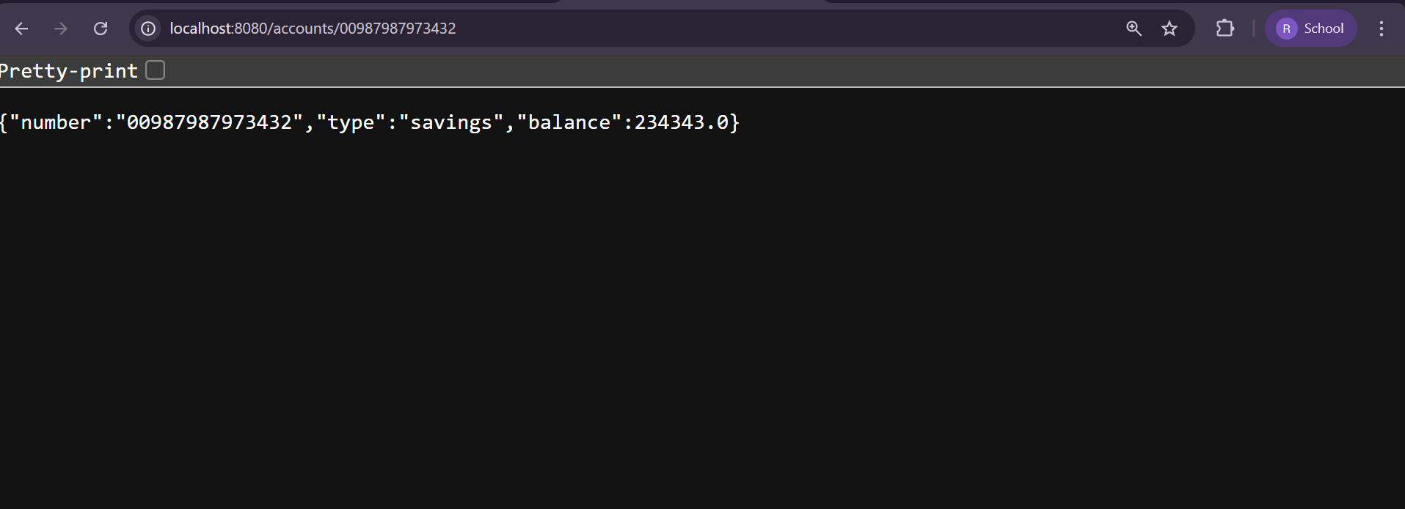

Create Loan Microservice

Step 1: Create the Project
Repeat the same process:
- File > New > Spring Starter Project
- Name: loan
- Group: com.cognizant
- Artifact: loan
- Package: com.cognizant.loan
- Add DevTools and Spring Web dependencies
- Click Finish

Step 2: Add Controller
Create class LoanController inside com.cognizant.loan. Use the following code:
package com.cognizant.loan;
import org.springframework.web.bind.annotation.*;
@RestController
@RequestMapping("/loans")
public class LoanController {
@GetMapping("/{number}")
public Loan getLoan(@PathVariable String number) {
return new Loan(number, "car", 400000, 3258, 18);
}
static class Loan {
private String number;
private String type;
private double loan;
private int emi;
private int tenure;
public Loan(String number, String type, double loan, int emi, int tenure) {
this.number = number;
this.type = type;
this.loan = loan;
this.emi = emi;
this.tenure = tenure;
}
public String getNumber() { return number; }
public String getType() { return type; }
public double getLoan() { return loan; }
public int getEmi() { return emi; }
public int getTenure() { return tenure; }
}
}

Step 3: Change Default Port
In src/main/resources, open or create application.properties and add:
server.port=8081

Step 4: Run and Test
- Run LoanApplication.java as Java Application
- Service will start on port 8081
- Test in browser or Postman: http://localhost:8081/loans/H00987987972342

OUTPUT: Loan Microservices
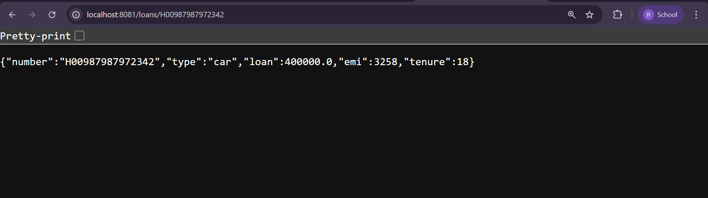

Final Setup
- Account microservice is running on http://localhost:8080
- Loan microservice is running on http://localhost:8081
- Both microservices are now fully functional and independently running in Eclipse

